|  |
| --- |
|  |
| **Al Imam Mohammad Ibn Saud Islamic University**  **College of Computer and Information Sciences**  **Computer Science Department** |
| |  | | --- | | **Software Engineering 1** |  |  |  | | --- | --- | | **Course Title:** | Software Engineering 1 | | **Course Code:** | CS290 | | **Instructors:** | Dr. Ibrahim Abdelmoniem Abdulmeguid | | **Semester:** | Second 2023/2024 |  |  |  |  |  | | --- | --- | --- | --- | | **Project Title** | Edrak | إدراك | | | | **Section No.** | **173** | **Group No.** | **3** |  |  |  | | --- | --- | | **Students Names** | **Students IDs** | | Abdulaziz Essam Alsheikh | 443016398 | | Osamah Sadeq Shubaytah | 444000350 | | Abdulaziz Mohammed Alkathiri | 444002181 | | Zaid Mohammed Alkhathlan | 444001475 | | Omar Khalid Alamoudi | 44400275 | | Nawaf Abdulhakim Alajlan | 443015858 | |

Contents

Edrak Team Manifesto 3

Our Standards: 3

Our Values: 4

Our Commitment: 4

2. Project scope: 5

3. Project objectives: 5

5. Clients: 5

6. Vision: 6

7. Features: 6

8. Product Backlog Creation: 7

8.1 All features required for the app: 7

8.2 Prioritization: 7

9. Requirements: 8

9.1 Functional Requirements: 9

9.2 Non-Functional Requirements: 10

Our Approach: 11

UI Prototypes: Login and Game Modules 14

Login Page: 14

Main Menu page design: 15

In Game Design: 16

UML 17

Context Diagram: 17

State Diagram: 18

Use Case Diagram: 19

Sequence Diagram Login / Register: 20

Sequence Diagram Gameplay: 21

Class Diagram: 22

Activity Diagram: 23

References: 24

Edrak Team Manifesto**:**

Welcome to Edrak Documentation,

At the College of Computer and Information Sciences, Imam Mohammed Ibn Saud Islamic University, we proudly present Edrak – an embodiment of our commitment to excellence, learning, and collaborative innovation. As a team dedicated to advancing education through technology, we hold ourselves to high standards and values that define our unique culture.

## Our Standards:

1. Open Communication:

- We foster an environment of open and transparent communication, where ideas, concerns, and feedback are cherished. Each voice contributes to our shared success.

2. Continuous Learning:

- Embracing a mindset of continuous learning, we seek opportunities for growth, ensuring that our skills remain at the forefront of technology.

3. Respect and Inclusivity:

- Respect and inclusivity guide our interactions. We celebrate diversity, creating a space where each team member's perspective is valued.

4. Quality and Excellence:

- Committed to delivering excellence, we take pride in every line of code and design choice, ensuring the highest quality in our solutions.

## 

## Our Values:

1. Empowerment:

- Edrak empowers each team member to take ownership of their work, fostering a sense of responsibility for the success of our educational initiatives.

2. Collaboration:

- Collaboration is at the heart of Edrak. We believe in the collective strength of our team, where together, we achieve more for the future of education.

3. Innovation:

- Innovation is embedded in Edrak's DNA. We encourage creative thinking, experimentation, and a vision that challenges the conventional, driving our commitment to cutting-edge solutions.

## Our Commitment:

As we document the journey of Edrak, let us commit to upholding these standards, values, and principles. Together, we will empower, learn, and innovate, creating not only exceptional educational products but also a culture where every team member thrives.

***Thank you for being an integral part of the Edrak family.***

# 2. Project scope:

Our software engineering project focuses on developing a suite of educational games tailored for children with autism. The scope encompasses a variety of interactive activities, including puzzles and learning games, designed to enhance cognitive, social, and motor skills in a supportive and engaging environment.

# 3. Project objectives:

1. Foster Skill Development: Create games that target key areas of development, such as problem-solving, communication, and fine motor skills.

2. Individualized Learning: Implement adaptive features to cater to each child's unique learning style and pace.

3. Sensory-friendly Design: Ensure a sensory-friendly interface, considering visual and auditory sensitivities to provide a comfortable user experience.

4. Parental Involvement: Incorporate features that allow parents and educators to track progress and customize activities based on the child's evolving needs.

**4. Target audience:**

Children diagnosed with autism spectrum disorder (ASD), aged 4 to 12 years, and their parents, caregivers, and educators.

# 5. Clients:

The clients for our app are foundations actively engaged in supporting individuals with autism, including the SA-AUTISM (autisticsociety), Society of Autism Families, Autism Center of Excellence, and collaboration with Special Education Centers.

# 

# 

# 6. Vision:

Together, we strive to create a positive impact on the lives of children with autism by providing them with accessible and enriching educational experiences.

To give the educational organization the ability to organize a fun, helpful and easy way to educate the children.

# 7. Features:

1. Engaging, sensory-friendly games designed to stimulate cognitive functions, enhance problem-solving skills, and promote joyful learning experiences.
2. Adjustable difficulty levels and adaptive challenges to cater to a diverse range of abilities within the autism spectrum, ensuring inclusivity for all users.
3. A thoughtfully crafted, sensory-friendly interface to ensure a comfortable and enjoyable gaming experience, respecting the unique needs of each child.
4. Features that cater to a diverse range of abilities within the autism spectrum, allowing every child to participate and benefit from the educational content.

By combining these features, our platform aspires to be a beacon of support, fostering a positive and inclusive learning environment for children with autism while providing valuable tools and insights to those involved in their care and education.

# 

# 8. Product Backlog Creation:

## 8.1 All features required for the app:

## 

- Catalog of interactive educational games and puzzles designed for autism education.

- Ensure a visually and auditorily comfortable interface to accommodate sensory sensitivities.

- Enable certain functionalities to work offline, providing accessibility without constant internet connectivity.

- User registration and login for parents, caregivers, and educators.

- Providing parents with insights into their child's engagement and progress within the game, without storing or tracking sensitive data, respecting privacy concerns.

## 8.2 Prioritization:

1. Sensory-Friendly Design: Crucial for ensuring a comfortable and inclusive environment.
2. Game Library: Fundamental to the app's educational purpose.
3. User registration and login for parents, caregivers, and educators.

# 9. Requirements:

|  |  |
| --- | --- |
| User Requirements | System Requirements |
| 1. Accessibility: the system must be accessible to children with autism, considering various levels of cognitive and sensory abilities. | 1. Scalability: The system must be scalable to accommodate a growing user base and evolving content. |
| 1. Intuitive Interface: The user interface should be intuitive, requiring minimal instructions for navigation and interaction. | 1. Data Security: Implement robust data security measures to protect user information and maintain privacy. |
| 1. Customizable Learning Paths: Users, including parents, caregivers, and educators should have the ability to customize learning paths based on individual needs and preferences**.** | 1. Responsive design: Adopt a responsive design approach to ensure optimal functionality and user experience across different devices and screen sizes. |
| 1. Engaging Visuals: The system should incorporate visually engaging elements that cater to the preferences of children with autism. | 1. Compliance with standards; Ensure compliance with relevant educational and accessibility standards to meet regulatory requirements known to norm. |

[1]

These user *and system requirements serve as a foundation for developing an inclusive and effective educational platform for children with autism. Adjustments and refinements can be made based on ongoing user feedback and evolving needs in development.*

# 

# 9.1 F**unctional Requirements:**

|  |  |
| --- | --- |
| Functional Requirements | RequirementsDetails |
| FR-1 | Creating a group of games that is suitable and enjoyable for the ones who have autism. |
| FR-2 | The User Interface (UI) must be autism-friendly, ensuring user friendliness and providing the individual to change the settings (colors…etc.) to more suitable experience. |
| FR-3 | A database that should save all the player's progress. |
| FR-4 | Creating a scoring system that motivates the player to continue playing the game. |
| FR-5 | Creating a final level of each game that the player must complete to finish the game. |
| FR-6 | The player must finish each level before proceeding to the next level. |

[1]

# 

# 

# 9.2 **Non-Functional Requirements:**

|  |  |
| --- | --- |
| Non-functional Requirements | Requirements Details |
| NFR-1 | Creating a simple UX, the UX should be autism-friendly providing comfort and catering to unique sensory requirements. |
| NFR-2 | Security; The application must enforce robust user authentication protocols and employ industry-standard encryption methods to safeguard sensitive user data against unauthorized access. |
| NFR-3 | Accessibility; The game should comply with accessibility standards, ensuring it is usable by individuals with diverse abilities. |
| NFR-4 | Compatibility; The application should be compatible with commonly used devices and browsers to maximize accessibility. |
| NFR-5 | Feedback Mechanism; The system should provide clear feedback to users during interactions, ensuring a positive and engaging experience. |
| NFR-6 | Regulatory Compliance; Ensure adherence to relevant data protection and privacy regulations to protect user information. |

# Our Approach:

During our research to address the sensory needs of children with autism, we uncovered valuable insights from the National Library of Medicine. This research indicates that children with autism often show preferences for colors such as blue, brown, and green. [2]

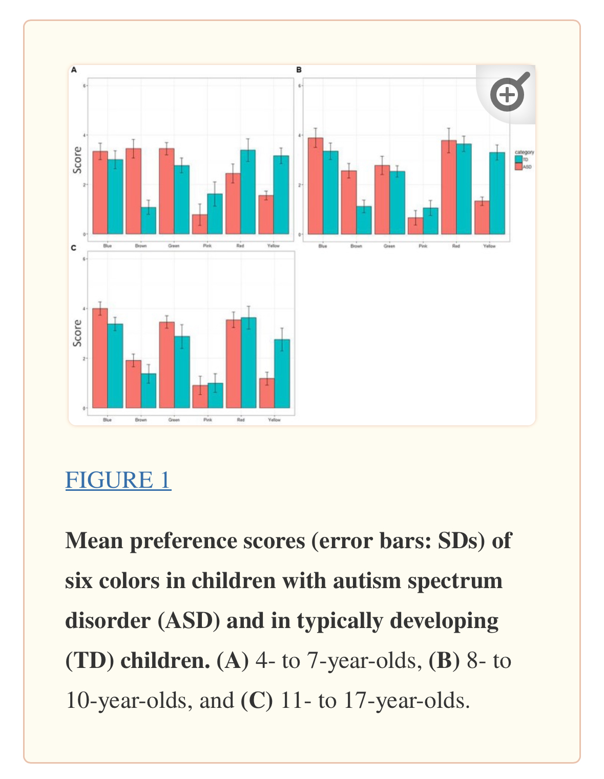

Considering the significance of color in creating a sensory-friendly environment, we are purposefully incorporating these preferred colors into the visual elements of our learning game. By aligning with the color preferences identified in the research, we aim to enhance the overall experience, ensuring that it is not only educational but also visually comforting for our young users.

This thoughtful selection of colors underscores our commitment to creating a learning game that resonates with the sensory preferences of children with autism, contributing to a positive and inclusive gameplay experience.

This addition highlights the use of specific colors in the learning game based on research findings, demonstrating a nuanced approach that caters to the sensory preferences of children with autism. [2]

We further enriched our design principles through additional research conducted by Irina Rusakova [3]. Research consultant with 14 years of experience in UX, Product, and Service Design. Our sensory-friendly UI design approach is now sturdier, with a focus on:

1. Structured Layout:

- Prioritize consistency and clarity, simplifying complex pages for an optimal learning environment.

2. Logical Content Presentation:

- Ensure logical and structured information presentation, facilitating easy comprehension and self-paced learning.

3. Accessible Text Design:

- Utilize simple text box designs, left-aligned columns, and clear fonts for enhanced readability in learning engagement.

4. Balanced Imagery and Content:

- Balance images and written content, leveraging clear visual elements and simple graphics to enhance learning comprehension.

5. Clarity in Visual and Verbal Elements:

- Prioritize plain language, using descriptive labels to enhance clarity in a learning context.

6. Calming Color Palette:

- Choose soft, mild colors with clear contrasts, acknowledging sensitivity to brightness for a visually comfortable experience.

7. Intuitive Navigation for Learning:

- Simplify and clarify game navigation with large, descriptive buttons for an enjoyable learning journey.

8. Engaging and Purposeful Interaction:

- Mindfully integrate animations that serve an educational purpose, avoiding intrusive elements for focused learning.

9. Personalization for Learning Preferences:

- Recognize the importance of personalization, allowing users to tailor the learning interface to their preferences.

Our obligation to delivering a high quality and well-studied design now draws on Irina's expertise, ensuring our learning game meets the needs of individuals with autism while creating an optimal and enjoyable educational experience for all users. Stay tuned for our upcoming visual design guide, distilling these principles into an easy-to-follow format, fostering inclusivity in the learning environment. [3]

We would like to note that after incorporating insights from the article "User Interface for People with Autism Spectrum Disorders" by Nikolay Pavlov, our project underscores the importance of steering clear from horizontal scrolling in our UI design. This aligns seamlessly with our aim to create an accessible and user-friendly interface. The article not only addresses challenges in reading comprehension for individuals with ASD but also provides actionable design recommendations, including the avoidance of bright colors and the implementation of clear fonts. Our project draws inspiration from this approach, ensuring that our UI design aligns with principles conducive to user engagement and accessibility. This perspective extends beyond ASD, offering valuable guidance for enhancing the usability of our specific GUI. [4]

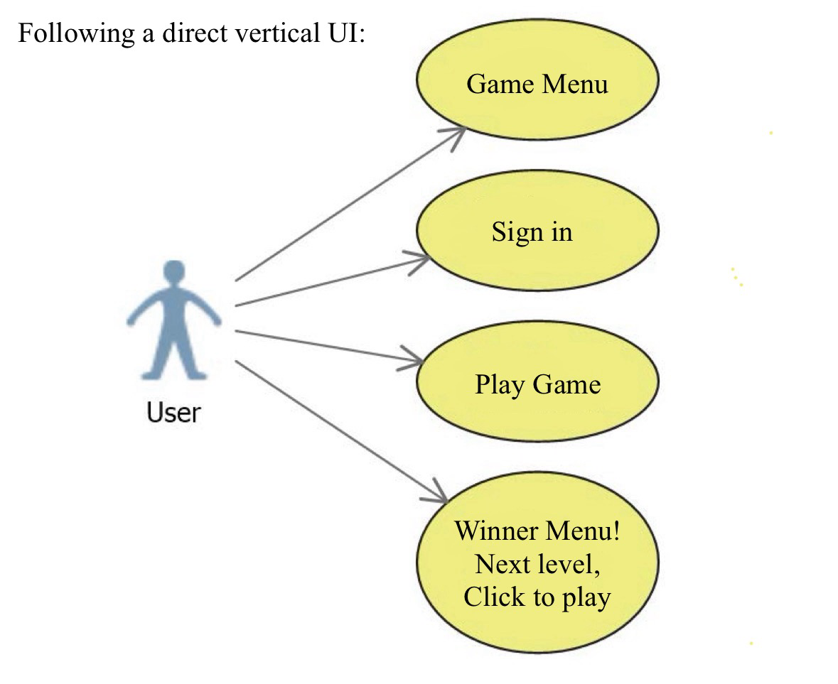

*Your feedback on this refined approach is invaluable as we strive to enhance the educational journey through thoughtful and inclusive design.*

# UI Prototypes: Login and Game Modules

## Login Page:

## 

## Main Menu page design:

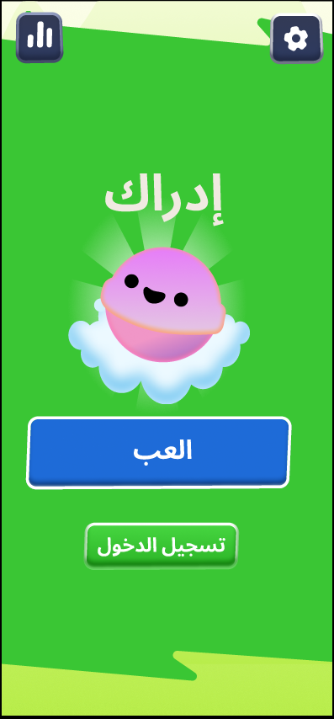

## 

## In Game Design:

# UML

## Context Diagram:

The Context Diagram for our Edrak system serves as a comprehensive visual representation, placing the Edrak system at the core. The diagram outlines crucial external entities connected to the system, including Google for login purposes, administrators, developers, and users (players). These entities interact with the Edrak system, forming a clear illustration of the relationships and dependencies within the broader system framework. This diagram is instrumental in understanding the contextual positioning of our system and its interactions with various stakeholders.

## 

## State Diagram:

In the State Diagram, the user journey within our Edrak game is systematically outlined. It commences with the user selecting a game, followed by the process of choosing the correct answer to the game question. If the answer is correct, the user's score increases, and they progress to the next level. On the contrary, an incorrect answer leads to advancing to the next level without a score increase. Upon completing all levels, the system displays the user's score and provides options to either return to the main menu (exit) or retry the game. Additionally, users can access the game settings by selecting the respective option. This State Diagram encapsulates the dynamic flow of user interactions within the Edrak game environment.

## 

## Use Case Diagram:

In our Use Case Diagram, we depict the various actors and their interactions within the Edrak system. Human actors include Admin, Player, and Parent/Teacher, while Admin serves as a Secondary passive actor. The Teacher is a Secondary active actor, and the Player is the Primary active actor. The Database, a non-human Secondary passive actor, links with login credentials exclusively during the registration process. The admin receives, controls, and reviews registrations, maintaining authority over this process. Parents/Teachers have the capability to view game reports externally, without affecting gameplay, and can access login credentials to monitor a child's progress. Players, the primary actors, engage in game activities by choosing to play, encompassing the entire gameplay interaction. Players can log in to save their progress, enhancing the overall user experience within the Edrak system.

## Sequence Diagram Login / Register:

In our Sequence Diagram representing login and registration, the player initiates the registration process by providing a username and password. The login function subsequently communicates with the database to input these credentials. The database, in turn, responds to the function, indicating the status of the login attempt—whether successful or not. Based on this response, denoted by a true or false status, the system determines the outcome of the login, thus validating or rejecting the player's access. This sequential representation illustrates the crucial steps involved in the player's interaction with the registration and login functions within the Edrak system.

## 

## Sequence Diagram Gameplay:

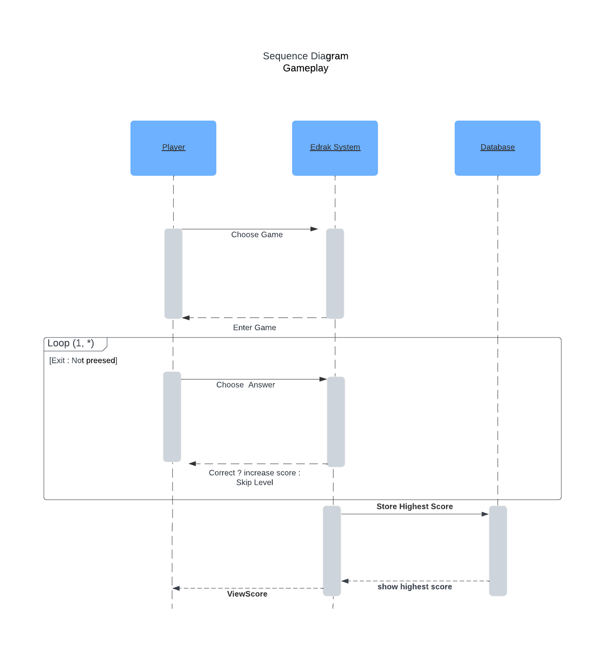

In our additional Sequence Diagram representing gameplay process, the player selects a game, initiating interaction with the Edrak system, which grants access to enter the chosen game. The system then enters a loop, presenting questions to the player, providing a chance to answer. If the answer is correct, the system interacts by incrementing the score; otherwise, it skips to the next question. Crucially, after completing the loop, the player exits, moving to the phase when the player achieves the highest score, the system communicates with the database to record this accomplishment. Subsequently, the information is transmitted back to the system, which displays the achievement to the player. This sequential representation captures the flow of interactions involved in the gameplay, scoring, and database recording within the Edrak system.

## 

## Class Diagram:

In our commitment to quality work, we embrace tools that enhance our processes. Employing the "Dart Class Diagram Generator," we automated the generation of class diagrams from our Dart package. To visualize these diagrams as images, we seamlessly integrated the PlantUML Visual Studio Code extension. The process involves a straightforward download of PlantUML to enable the visualization of diagrams as images. Following this, we conducted a thorough review and editing process of the UML, ensuring alignment with our project's classes, and maintaining the quality of our code architecture.

Therefore, in the class diagram, we showcase the key classes pertaining to the code structure. Class 1 represents the "Main Menu," serving as the entry point. Class 2 corresponds to the "Login Page," facilitating user authentication. Class 3 embodies the core functionality of the "Game," orchestrating the gameplay. Lastly, Class 4 encapsulates the "Result Page," showcasing the user's final score. The navigation path unfolds as users transition from the Main Menu, offering choices to either log in or play without logging in—acknowledging the potential loss of progress in the latter case. The journey progresses to the Game class, where the gameplay unfolds, and finally leads to the Result Page, revealing the user's score. The integration of widgets is illustrated, accentuated by celebratory actions, such as confetti, enhancing the user experience throughout this navigational journey.

## Activity Diagram:

In the Activity Diagram, the sequence unfolds with a straightforward series of actions. The user initiates the process by pressing "Start," prompting the commencement of the game. As the game progresses, the user answers questions, and if correct, the score increments. Regardless of the correctness of the answer, the system transitions to the next level. The cycle continues until the user decides to conclude the game. This simplified portrayal captures the fundamental activities within the game, offering a clear visual representation of the sequence from the start to the end of the gameplay.

# References:

|  |  |
| --- | --- |
| [1] | I. Sommerville, Software Engineering, 10th ed., England, Harlow: Pearson Education Limited, 2016, p. 107. |
| [2] | M. G. a. N. Masataka, Atypical Color Preference in Children with Autism Spectrum Disorder, National Library Of Medicine, 2016. |
| [3] | ]. Rusakova, Designing for autistic people — overview of existing research, Medium, 2020. |
| [4] | N. Pavlov, User Interface for People with Autism Spectrum Disorders, Polvdiv, Bulgaria: Scientific Research, 2013. |